A GAN-Driven Educational Sandbox-Lab
Solomon Negash
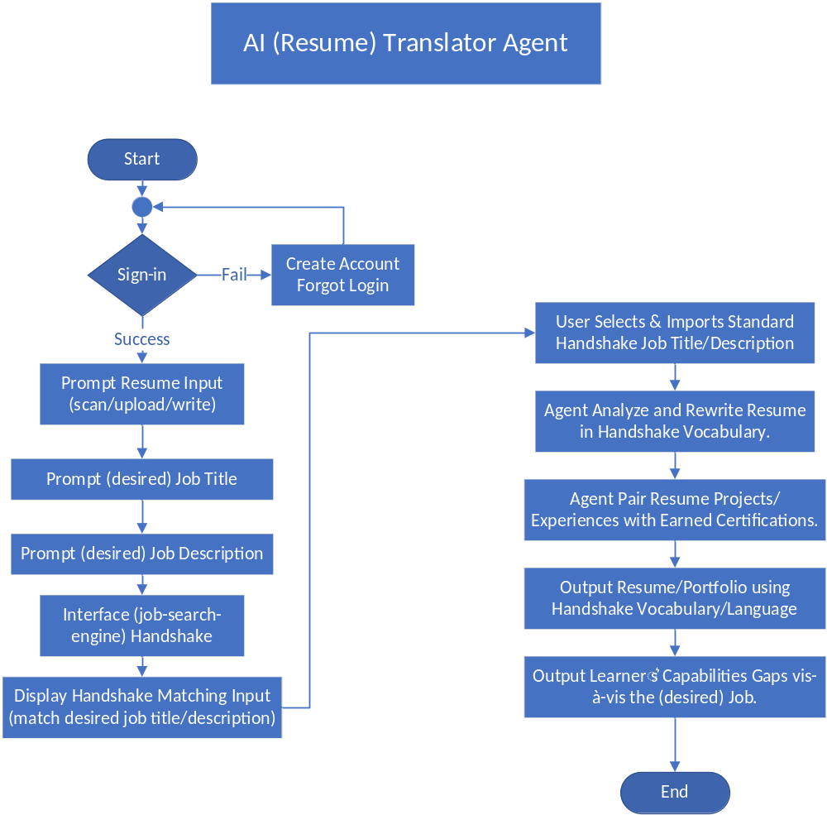

[1. Brief elevator pitch to investors.]
Regulatory FinTech sandboxes have proven highly effective in helping startups safely test innovative financial products within structured compliance environments. Yet higher education lacks an equivalent mechanism to prepare talent for the realities of the FinTech workforce. Today, many graduates accumulate certifications and theoretical knowledge but struggle to demonstrate applied, job-ready capabilities that employers can trust and immediately deploy.
We are addressing this gap by building a GAN-Driven Educational FinTech Sandbox-Lab -a next-generation talent development platform modeled directly after regulatory sandboxes, but purpose-built for education and workforce readiness. The sandbox creates a fail-safe experimentation environment where learners, employers, and trainers collaboratively design, prototype, and test capabilities aligned with market demand and regulatory expectations.
At the core of the model is a Generative Adversarial Network (GAN) architecture. The Generator learns from regulatory FinTech sandbox practices to continuously design innovative, industry-relevant learning scenarios, while the Discriminator evaluates outcomes against educational rigor, ethical standards, and workforce relevance. This AI-driven feedback loop ensures that innovation remains grounded, responsible, and employment-focused.
The platform integrates three critical data streams: learner profiles derived from resumes and experience; academic inputs such as courses, assessments, and certifications; and real-time labor market intelligence reflecting employer demand. Through iterative, project-based experimentation, learners convert static credentials into validated portfolios that demonstrate real problem-solving capability, regulatory awareness, and collaborative competence.
Beyond technology, the sandbox is grounded in a human-centered ethos of empathy, gratitude, and responsible innovation --encouraging participants to experiment, fail, learn, and grow without harm. For investors, this represents not just an ed-tech solution but a scalable workforce infrastructure that reduces hiring friction, accelerates career transitions, and strengthens university-industry innovation ecosystems in the AI-driven economy.

[2. Describe Your Audience]
Pilot Audience: FinTech students mentored by an industry expert in an Online experiential learning course. A mix of graduate and undergraduate students taking their capstone course in a FinTech degree program. This pilot will award participating students extra credit class points. The pilot study survey will include age group, employment history, graduate/undergraduate, gender, and career path.
Target Audience: Stakeholders’ trio (learner, employer, trainer) who collaborate to transition the learner into employment through a project-based capabilities portfolio.
We used the Double Diamond (Discover, Define, Develop, and Deliver) technique.

[3. DISCOVER]
Stakeholders' pain points and needs:
(1) Learners: Approximately 58% of college graduates do not transition to a full-time job six months after graduation.
(2) Employers: Half the hiring managers are hesitant to hire fresh graduates, reporting that new grads lack necessary industry-specific experience.
(3) Universities: Colleges are increasingly focusing on career readiness to bridge the workforce gap, with 83% implementing competencies. Ninety-seven percent (97%) of higher education leaders identify economic development as a top priority.
(4) Education-Industry: Education-industry partnerships are shifting from experimental collaborations to essential, integrated, and sustainable ecosystems designed to close critical skills gaps, particularly as the "demographic cliff" reduces the number of traditional college-aged students. Key trends for 2026 highlight a focus on workforce readiness, AI integration, and the rise of stackable.
(5) Measurable Organizational Value (MOVs and KPIs):
- Overall value measure: Measured by upward trend in education-industry partnerships, an increase in internships (virtual and in-person), a percentage improvement in transitioning learners to their desired job or promotion, and the sustainability of the collaboration.
- Pilot value measure (KPIs): (a) Learners: Percentage of total enrolled students who see value in this pilot and participate. (b) Industry: Dedicated hours and lessons mentors (industry experts) allocate to support and promote the pilot. (c) University: Resources committed/promised by directors and administrators supporting the pilot. (d) Trio (learner/employer/trainer) agreements/disagreements to support and sustain the pilot in the long-run.

[4. DEFINE]
The pilot objectives are to (1) conduct a 'thought experiment' and (2) develop an MVP translating learner resumes to the desired job/promotion language.
The thought experiment will deliver quick insight before an MVP. And the MVP will deliver a meaningful value for the trio (learner, employer, university) to begin assessing the gap between the desired job and current skills.

[5. DEVELOP]
The pilot phase will begin with a structured thought experiment to conceptually test the Educational FinTech Sandbox and its multi-agent AI architecture. This exploratory stage will allow stakeholders — learners, trainers, and industry partners — to simulate workflows, validate assumptions, and refine ethical, pedagogical, and operational boundaries before full implementation. Insights generated from the thought experiment will directly inform the design of a Minimum Viable Product (MVP).
(1) Thought experiment: Prior to sandbox implementation, a thought experiment will be conducted on the GAN-driven educational sandbox lab.
- Employers/Trainers: (i) Interview domain experts for feedback on the overall educational sandbox concept and the proposed AI agents. (ii) Ideate on the fundamentals of educational sandboxes, provide recommendations on future direction. (iii) Identify AI cancers and risks.
- Learners: (i) Collect survey data from learners on user interfaces and sandbox features. (ii) Identify AI cancers and risks. (iii) Collect demographic data: Online vs. F2F student, professional employment history – novices and experienced, and prior experiential learning engagement.
(2) MVP. Develop an MVP (Minimal Viable Product) app.
Inputs: (i) Learners' resumes. (ii) Desired Handshake job/promotion title. (iii) Desired Handshake job/promotion description. And (iv) Learner profile data, with permissions, to remain relevant/current on learner skills.
Output: Translated resume into the language of the desired job/promotion.
Proposed AI agents:
1. [Translator Agent]. The AI Translator Agent evaluates a learner’s resume and transforms it into the language of opportunity competencies required for a specific job, promotion, or industry role.
2. [Talent Predictor Agent]. The AI Predictor Agent analyzes business signals, industry trends, and workforce data to forecast emerging talent needs.
3. [Curriculum Agent]. The Curriculum Agent is an AI-driven orchestration layer that continuously updates and aligns course offerings, learning outcomes, and experiential projects with evolving talent demand.
4. [Recommendation Agent]. The Recommendation Agent identifies a learner’s capability gap relative to a targeted job/promotion and recommends the best-fit courses, certifications, and sandbox projects to close that gap.
5. [Filter Agent]. The Filter Agent is an AI governance component that monitors dialogue between learners, industry mentors, and academic stakeholders to detect and flag potential disclosure of competitive, confidential, or proprietary information, not surveillance, but protective mediation enabling open collaboration while safeguarding organizational trust and compliance.
6. [Generator Agent]. The Generator Agent is the generative intelligence component of the GAN-driven Educational Workforce Sandbox. Drawing lessons from regulatory FinTech sandboxes, it continuously proposes enhancements to the educational sandbox — including new learning scenarios, project designs, governance practices, and curriculum adjustments — to keep the ecosystem current, innovative, and workforce-relevant.
7. [Discriminator Agent]. The Discriminator Agent is the evaluative intelligence of the GAN-driven Educational Workforce Sandbox. Its role is to critique, test, and validate the Generator Agent’s proposed changes to the educational sandbox, ensuring they remain aligned with the program’s educational mission and workforce outcomes. In GAN terms, the Discriminator does not merely reject or accept; it provides high-quality feedback that systematically improves the Generator’s outputs over successive iterations.
8. [Crowdfunding Agent]. The Crowdfunding Agent identifies and mobilizes decentralized funding sources to support learners as they transition from unemployment or underemployment into demonstrable, project-based capabilities. By leveraging crowdfunding models, digital sponsorships, and community-backed investment mechanisms, the agent enables equitable access to experiential learning opportunities within the Educational FinTech Sandbox-Lab.
Theoretical Underpinning. The pilot tests situational, evolutive, and transformative learning approaches.
- Situational Learning. Situational learning requires authentic engagement with real-world FinTech challenges. Employers contribute current industry use cases, enabling learners to work within realistic regulatory, technological, and organizational contexts. Trainers integrate these use cases into course offerings, aligning curriculum with evolving industry practices while providing domain-specific expertise. Through this structure, learning moves beyond theoretical instruction toward applied capability development grounded in professional practice.
- Evolutive Learning. Evolutive learning emphasizes a continuous, iterative, and digitally connected environment. Trainers design fail-safe sandbox experiences that encourage experimentation, rapid feedback, and adaptive improvement. Learners are empowered to test ideas, learn from failure, and refine solutions through guided iteration. This evolutive process fosters resilience, innovation, and sustained engagement, enabling learners to develop competencies aligned with dynamic workforce demands.
- Transformative Learning. Transformative learning emerges as learners actively engage in both situational and evolutive experiences. Through reflective practice, collaborative experimentation, and project-based work, learners reconstruct their professional identity — transitioning from certification holders to capability-driven practitioners. The outcome is a validated, project-based portfolio that demonstrates applied expertise, regulatory awareness, and readiness for employment or career advancement.

[6. DELIVER]
A survey will be conducted to operationalize the thought experiment. The MVP will test the first AI agent in the process - Translator Agent.
Pilot KPIs:
(a) Learners: Percent students who volunteer and participate in the pilot.
- The thought experiment will use a five-point agree/disagree Likert scale question to learn from participating students.
- The MVP will create an interface for students to upload their resume, create an interface to Handshake, select a Handshake job title, and enter a Handshake job description.
(b) Industry: Dedicated hours and lessons mentor (industry expert) allocates to support and promote the pilot.
- The thought experiment will include an interview with industry mentors/experts to gauge the fundamental physics of the sandbox and to ideate future directions.
- The MVP output - translated initial learner’s capabilities - will be validated by industry mentors/experts.
(c) University: Additional resources committed/promised by directors and administrators supporting the pilot.
- The thought experiment interview will gauge Directors/Admins' support for the sandbox. Enumerate resources committed by directors and administrators.
- The gap resulting from the MVP translated job/promotion will be critiqued by university directors and administrators for possible alignment of course offerings.
(d) We will secure the trio’s (learner/industry/university) level of support to sustain the pilot in the long-run.

[7. REVIEW]
Planned activities:
1. Immediate (4-6 weeks): (i) Garner technical support - develop the translator agent. (ii) Develop and conduct the thought experiment survey. (iii) Create a system diagram/flowchart (Figma). (iv) Develop and test the MVP code.
2. Short-term (2-3 months): (i) Garner engineering support - confirm the sandbox fundamentals. (ii) Update design based on survey feedback. (iii) Develop two more AI agents: the talent predictor and curriculum agents. (iv) Integrate with the MVP and evaluate.
3. Intermediate (6-months): (i) Garner administrator support - secure resources. (ii) Identify external funding mechanisms. (iii) Develop and conduct Alpha testing.
4. Long-term (12-18 months): Beta testing.

